**Project and Developer Details**

**Project Name: LockedMe.com (Virtual Key for Your Repositories)**

**Project Details:**

It is file management system, which creates a root directory by creating a bin folder in the file application.

It is a file management system, in which it creates a root directory by creating a bin folder. It performs following operation as per problem statement:-

Generic features and three operations:

1.Retrieving the file names in an ascending order

2.Business-level operations:

Option to add a user specified file to the application

Option to delete a user specified file from the application

Option to search a user specified file from the application

Navigation option to close the current execution context and return to the main context

3. Option to close the application

**Developer Name: Ashish Tarkeshwar Singh**

**Sprint Details for the project**

**No. of Sprints Planned:** 2

**Sprint 1 Details:**

In the first sprint a basic structure to the application was developed, with the simple capability of listing the files present in the root directory.

This basic structure was created using various classes and interfaces. Also the logic to list the files present in the root directory was developed.

**Sprint 2 Details:**

The above application was enhanced to incorporate additional features like addition/ removal/ search of a file.

This included creating a submenu. And adding the above options. New methods had to be created for this purpose.

**Application Logic/algorithm/flowchart**

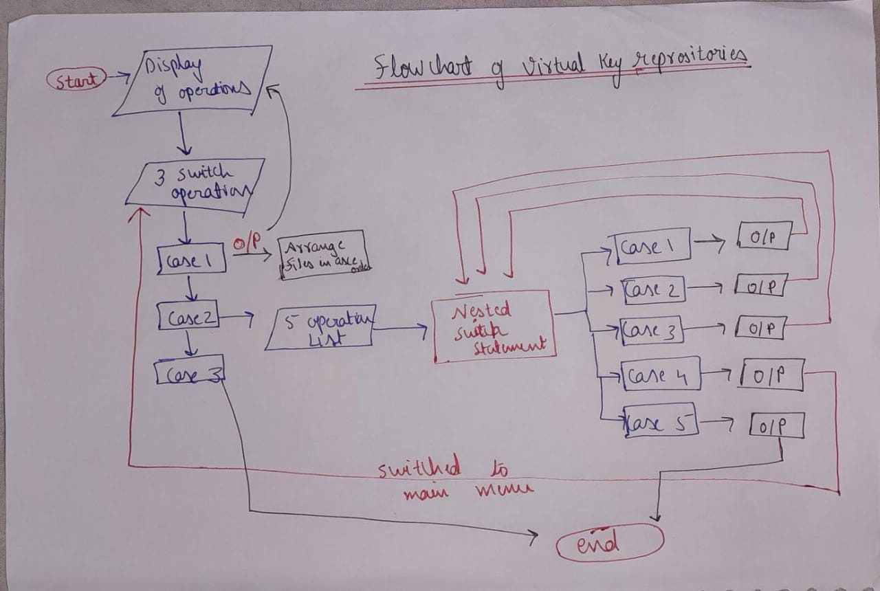

**Core concepts used in the project**

Java concepts implemented in this application:

1. Classes
2. Interface
3. File Handling Concepts
4. Constructors
5. For, While, Switch Case, If-Else, and other logic related functions.

**Links to the GitHub repository to verify the project completion**

**Conclusion**

There is a huge scope of improvement in the present project, one can easily add the functionality for navigating within folders, and adding, deleting files within a folder of the root directory. Also a functionality to write within the text files can be added.

Through This project we can Simply made File Management System by enhancing our UI and it acts as a full fledge file management System.